W-12
YEAR 10 SCIENCE
CHEMICAL SCIENCE
REVISION - ATOMIC STRUCTURE, PERIODIC TABLE

1. The periodic table is useful for chemists as it arranges the elements in a particular way.

(a) What is a group?

(b) Why are elements put into a particular group?

(c) What are the group numbers of:

(i) alkali metals?

(ii) inert (noble) gases?

(iii) halogens?

(d) Where do you find the following elements in the table? Indicate them on the periodic table below, either
by labelling or colouring.

(i) transition elements
(ii) metalloids / semi-metals

(e) Where do you find the non-metal elements? Show this on the diagram below.

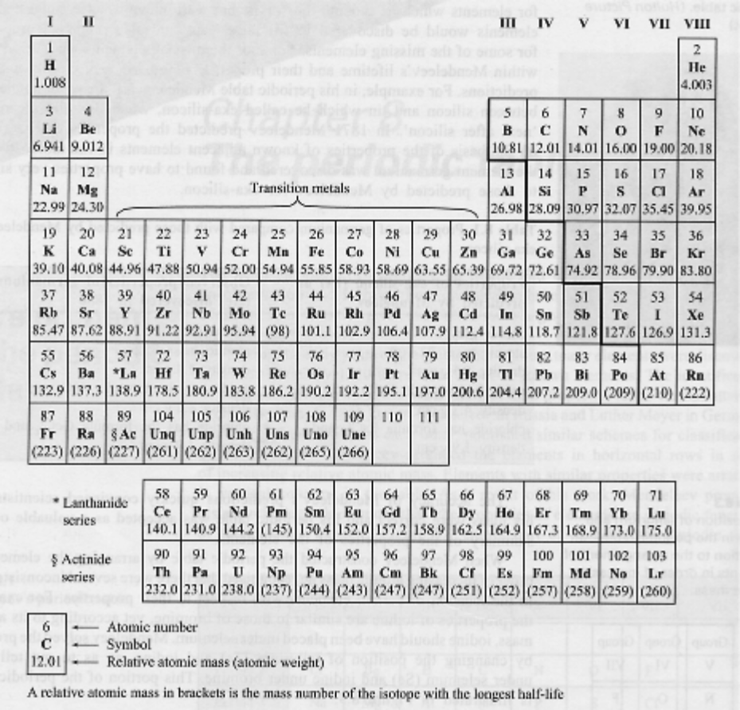

2. Give a definition or description for the following terms.

(a) atom

(b) proton

(c) neutron

(d) element

(e) molecule

(f) compound

(g) period

(h) atomic number

(i) atomic mass

3. Write the name or symbol as required to complete the following table.

ELEMENT | SYMBOL
sodium
helium
chlorine
manganese
gold
nitrogen
argon
lithium
copper
silver
ELEMENT | SYMBOL
 | Fe
 | Al
 | K
 | Pb
 | Zn
 | C
 | Si
 | H
 | N
 | Ne

4. Complete the following table.

ELEMENT | PROTON NUMBER | NEUTRON NUMBER | ELECTRON NUMBER
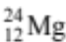
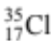
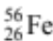
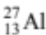
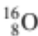

5. Draw clear diagrams to show the electron configurations of the following elements.

(a) (b) 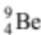

(c) 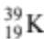 (d) 